Mozambique

## Political Stability Estimate Data

The data set shows the political stability estimate of the country each year.

## # A tibble: 19 x 5  
## country iso3c date stability stabilityCategory4   
## <chr> <chr> <dbl> <dbl> <chr>   
## 1 Mozambique MOZ 1996 -0.0496 moderately unstable  
## 2 Mozambique MOZ 1998 0.113 moderately stable   
## 3 Mozambique MOZ 2000 -0.125 moderately unstable  
## 4 Mozambique MOZ 2002 0.186 moderately stable   
## 5 Mozambique MOZ 2003 0.246 moderately stable   
## 6 Mozambique MOZ 2004 0.00237 moderately stable   
## 7 Mozambique MOZ 2005 0.125 moderately stable   
## 8 Mozambique MOZ 2006 0.520 moderately stable   
## 9 Mozambique MOZ 2007 0.358 moderately stable   
## 10 Mozambique MOZ 2008 0.382 moderately stable   
## 11 Mozambique MOZ 2009 0.626 moderately stable   
## 12 Mozambique MOZ 2010 0.394 moderately stable   
## 13 Mozambique MOZ 2011 0.332 moderately stable   
## 14 Mozambique MOZ 2012 0.390 moderately stable   
## 15 Mozambique MOZ 2013 -0.227 moderately unstable  
## 16 Mozambique MOZ 2014 -0.336 moderately unstable  
## 17 Mozambique MOZ 2015 -0.514 moderately unstable  
## 18 Mozambique MOZ 2016 -1.09 highly unstable   
## 19 Mozambique MOZ 2017 -0.976 moderately unstable

## Political Stability Estimate Plot

The plot shows the trends of stabilization and destabilization for the each country.

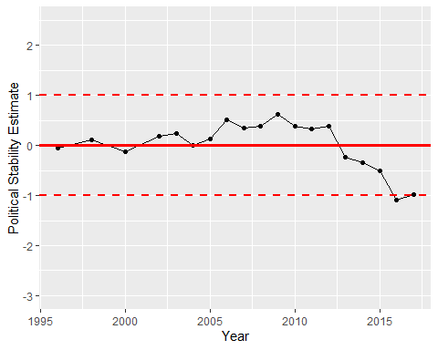

Political Stability Trend